Report for foundation Alphabet Soup

**OVERVIEW**

The nonprofit foundation Alphabet Soup wants a tool that can help it select the applicants for funding with the best chance of success in their ventures. With the knowledge obtained of machine learning and neural networks, we’ll use the features in the provided dataset to create a binary classifier that can predict whether applicants will be successful if funded by Alphabet Soup.

**RESULTS**

* What variable(s) are the target(s) for your model?

The target of the model is the success column, depending of that, the model will be trained for future inputs.

* What variable(s) are the features for your model?

The features will be all the columns that we can group by their value and convert it into a number (1, 0).

* What variable(s) should be removed from the input data because they are neither targets nor features?

We are going to drop the first two columns (name & ein), because that information cannot be transformed in binary.

Target

Features

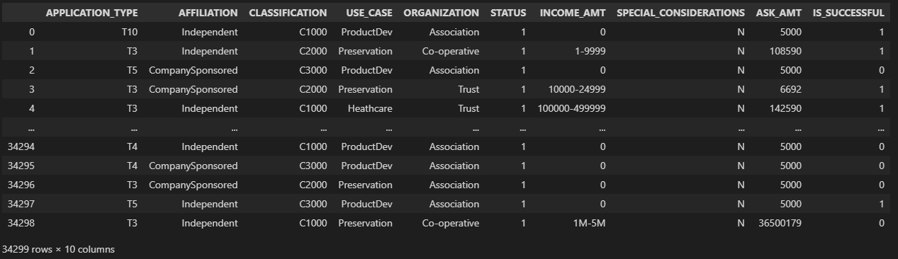

* How many neurons, layers, and activation functions did you select for your neural network model, and why?

I used 3 hidden layers with 80, 50 and 30 neurons each, and to be honest I think this structure is not the better but I fund a little improvement in the accuracy.

* Were you able to achieve the target model performance?

The maximum accuracy achieve it was 74%, it took to many attempts because no matter how many layers or neurons add, it was stuck in 73%.

* What steps did you take in your attempts to increase model performance?

I tried increasing the layers and neurons, then I decided to bin fewer rare categories in the ‘Classification’ column, that change increased the accuracy.

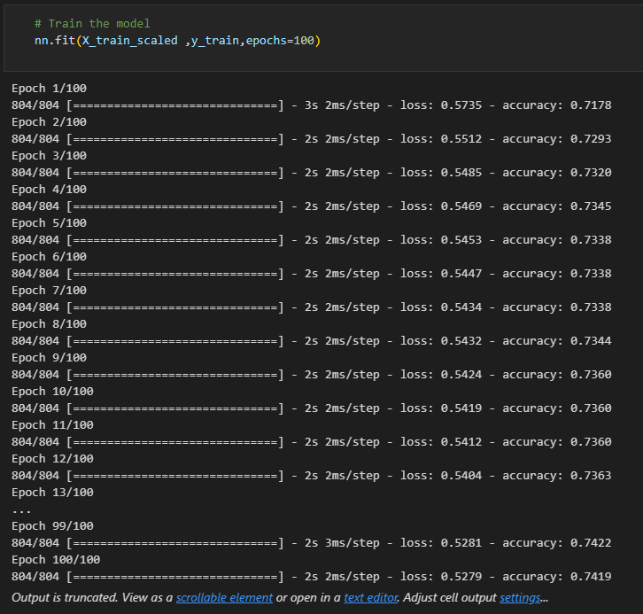

**CONCLUSION**

I think this neural network model is great and very complete, but would be interesting if we implement simpler models like Logistic Regression or K- means clustering and compare the results to see the accuracy and choose the best of them.